EC2 Ubuntu Lab: Password Authentication and SSH Key Authentication
Objective Configure SSH connectivity between two Ubuntu EC2 instances using both Password Authentication and Password-less SSH Key Authentication.

Lab Environment

Source Server: Ubuntu EC2

Target Server: Ubuntu EC2

User Accounts: ubuntu / custom users

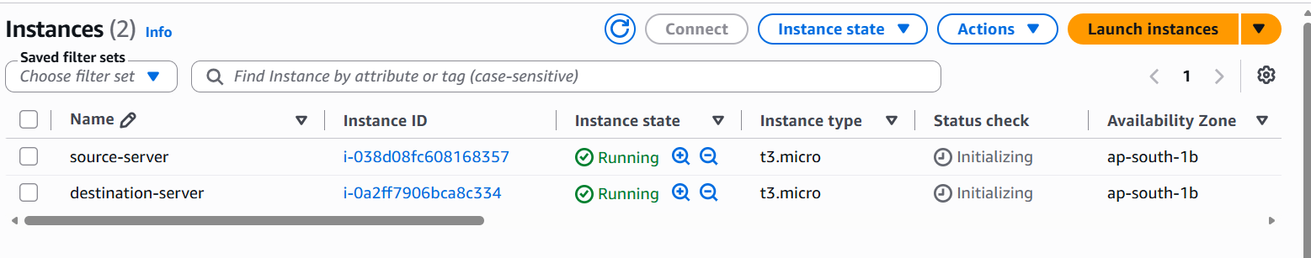

Method 1: Password Authentication
Step 1: set password for ubuntu user on destination-server
sudo passwd ubuntu
Step 2: SSH Configuration
sudo vi /etc/ssh/sshd_config
PasswordAuthentication yes
KbdInteractiveAuthentication yes
UsePAM yes
sudo systemctl restart ssh
Chack ssh status
Systemctl status ssh
Go to source server-
ssh ubuntu@server-privet-ip
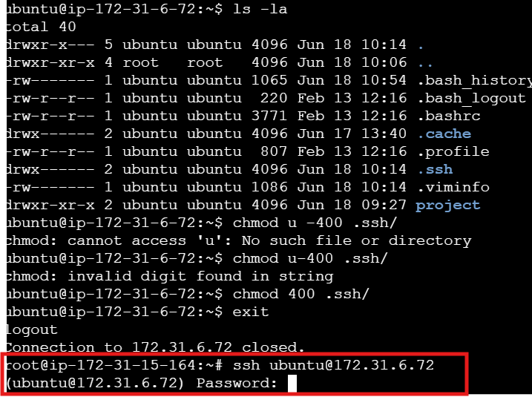
Successfully accessible destinations server
Method -2 SSH Key Authentication (Recommended)
source-server:
ssh-keygen -t ed25519 -C "server1-to-server2"
Host Public Keys
~/.ssh/id_ed25519 - privet key
~/.ssh/id_ed25519.pub -public key
send a public key to a remote server:
cat ~/.ssh/id_ed25519.pub | ssh ubuntu@SERVER2_IP "mkdir -p ~/.ssh && chmod 700 ~/.ssh && cat >> ~/.ssh/authorized_keys && chmod 600 ~/.ssh/authorized_keys"

Ssh ubuntu@ Private IPv4 addresses
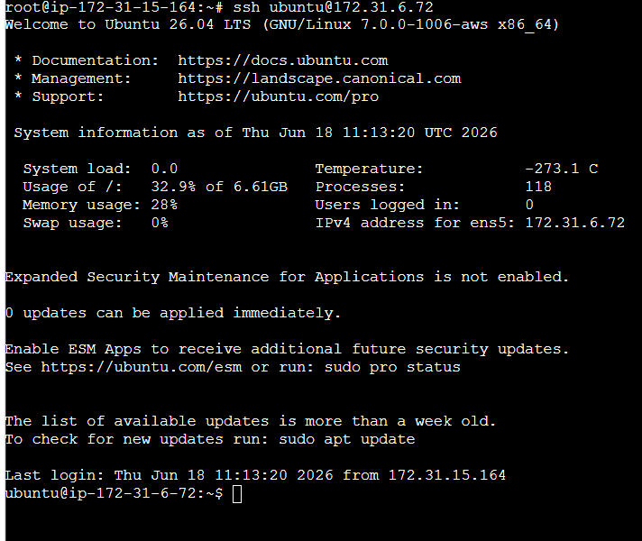
Successfully accessible destinations server
Production Best Practice- in production, SSH key authentication is generally preferred, and password authentication is often disabled to improve security

